B39SB Time and Frequency Signal Analysis

Tutorial 1 on Signals and Spectra - Solutions

------------------------------------------------------------------------------------------------------------------------
Energy of 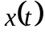 is 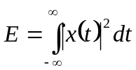. Power of a signal is 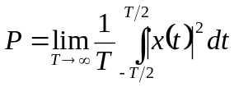
The bandwidth of a signal is the difference between the highest and the lowest frequencies of the spectral components of the signal. A signal is said to be a band-limited signal if the amplitude of its spectrum goes to zero for all frequencies beyond some threshold called the cutoff frequency.
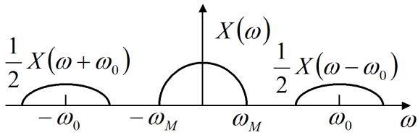
The Modulation theorem: if 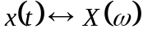, then 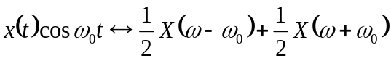
------------------------------------------------------------------------------------------------------------------------

P1. Find the power of a sinusoid 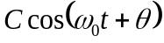 Ans. 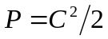

P2. Find the complex Fourier coefficients 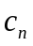 for the periodic signal 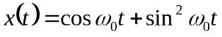.
Ans. . All the other coefficients are equal to zero.

P3. Find the Fourier transform of 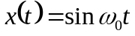 Ans. 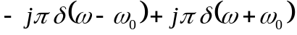

P4. A signal 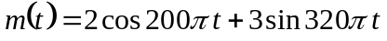 is ideally sampled at 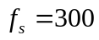 Hz. If the sampled signal is passed through an ideal low-pass filter with cutoff frequency of 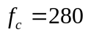 Hz, what frequency components will appear at the output? Justify your answer.
Ans. 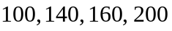-Hz components.

P5. A signal is ideally sampled at Hz. If the sampled signal is passed through an ideal low-pass filter with cutoff frequency of 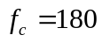 Hz, what frequency components will appear at the output? Justify your answer.
Ans. 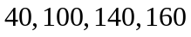 Hz components.

P6. Let 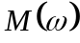 be the Fourier transform of a signal 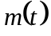. Find the Fourier transform of 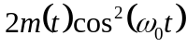. Ans.

P7. Find the frequency response of the network shown below
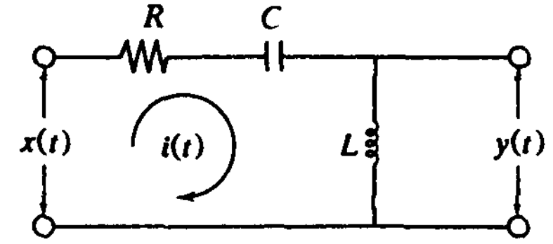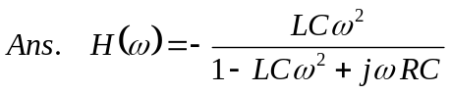

Brief Solutions

P1. Find the power of a sinusoid

P2. Find the complex Fourier coefficients for the periodic signal .
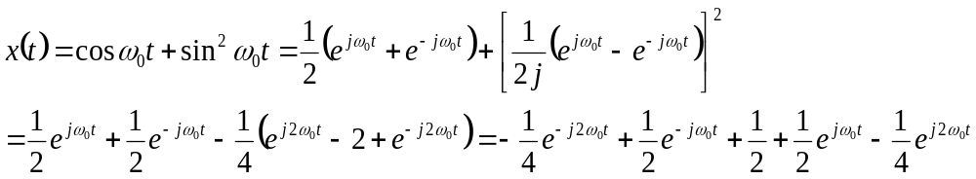

P3. Find the Fourier transform of
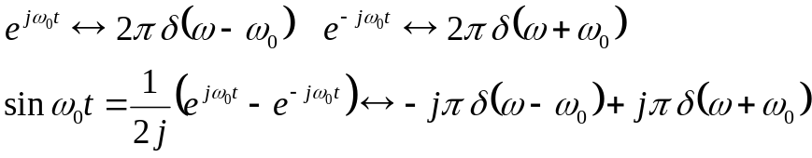

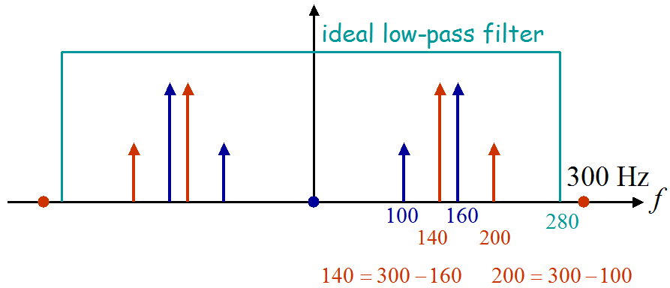
P4. Notice that Hz is smaller than the Nyquist frequency320 Hz for this signal. The figure below illustrates that Hz frequency components appear at the filtered signal.

P5. Notice that Hz is smaller than the Nyquist rate 320 Hz for this signal. The figure below illustrates that Hz frequency components appear at the filtered signal.
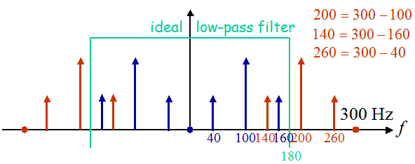

P6. We have and, therefore,
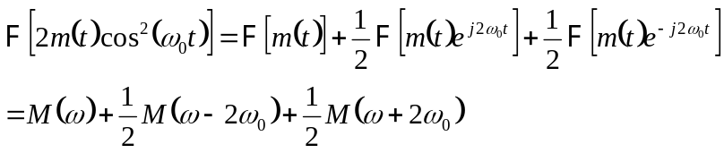.

P7. Find the frequency response of the network shown below
Assume that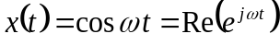. Let 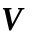 denote the phasor corresponding to. Then the phasor corresponding to the voltage across is given by
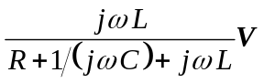. Thus 

